1. **Hello World:**

In the `console.log()`, print `"Hello, World!" `.Folder Name: `Question1`

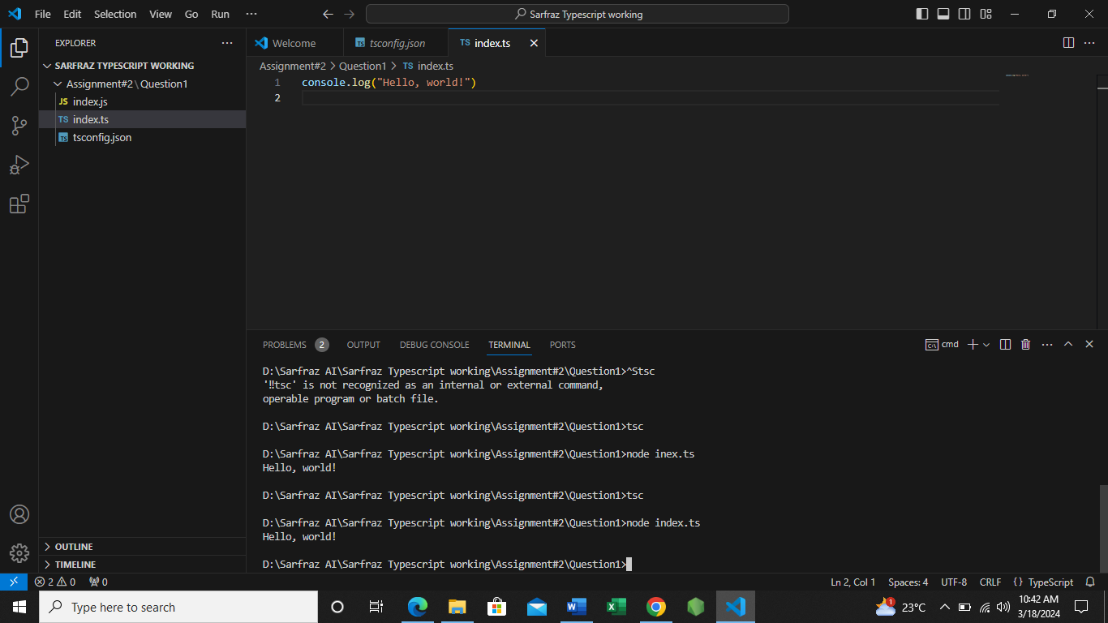

2. **Current Date:**  
In the `console.log()`, print `"Today Date : 18-March-2024"`.Folder Name: `Question2

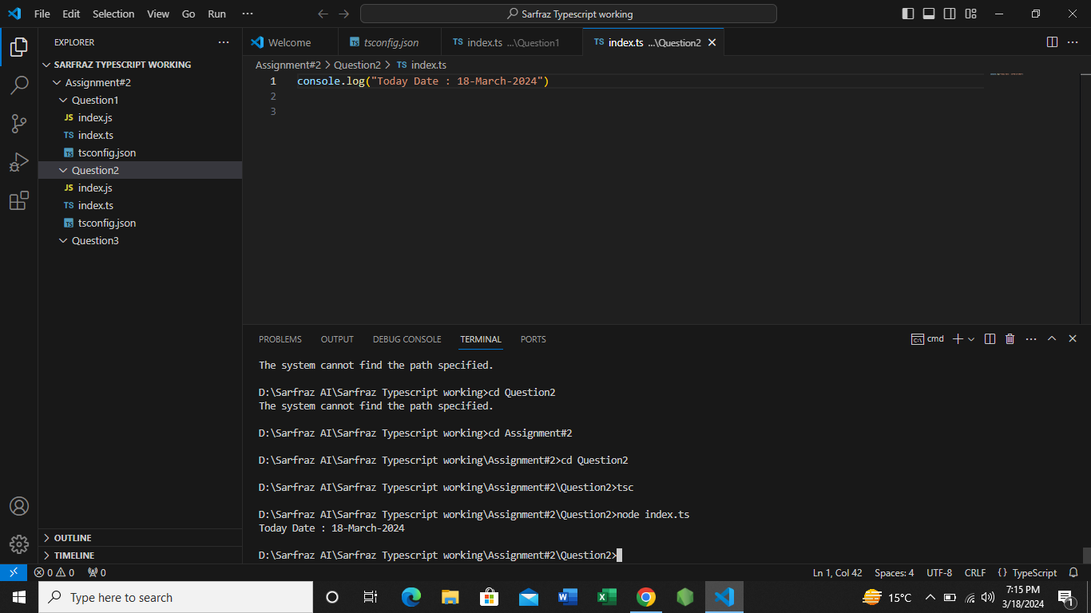

3. **Random Number:**  
Print a random number between 1 and 100. Folder Name: `Question3`

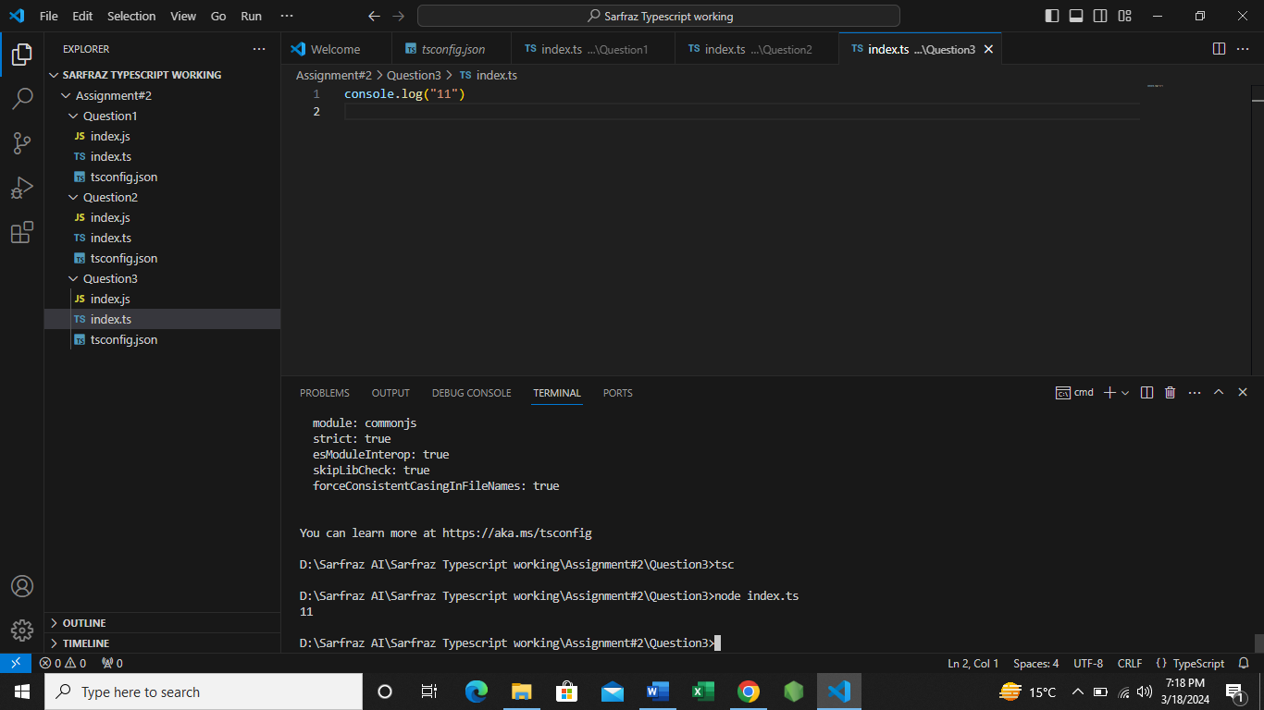

4. **Your Name:**  
Print `"Hello, "`, followed by your name (you can use any name). Folder Name: `Question4`

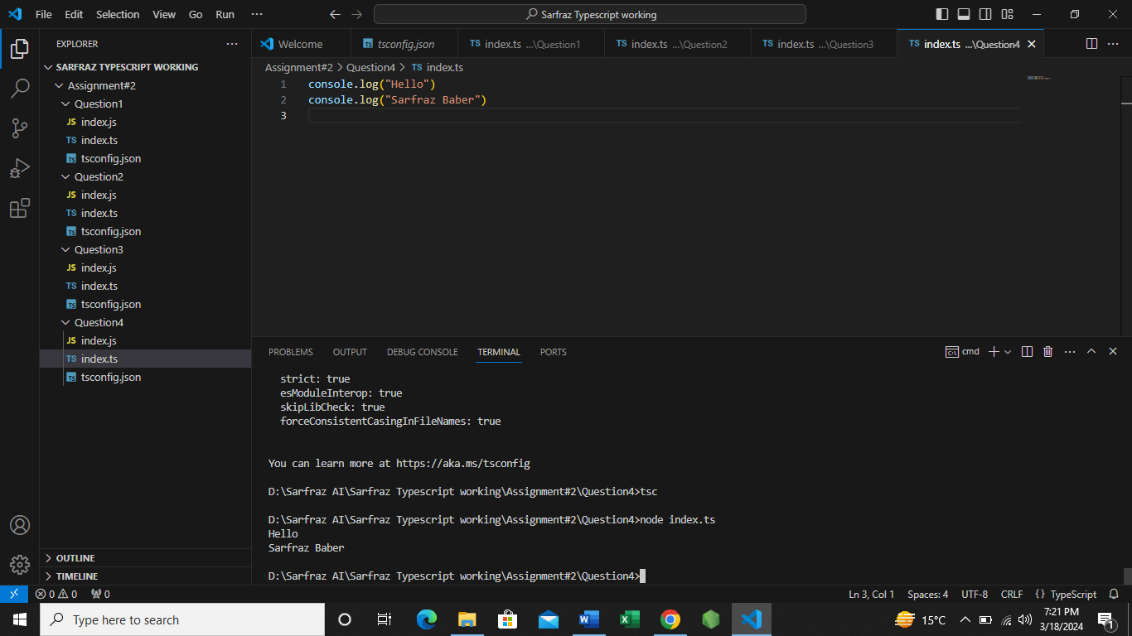

5. **Favorite Quote**:  
Print your favorite quote or any motivational quote. Folder Name: `Question5`

